Executive Director, Clarisse Mefotso Fall and Vice Chair, Terrylynn Smith received special invite for Book drive organized by Z. HOPE Sororities May 2013 during their Annual event |  | La Source  - African Hope Committee Global Journal  - FALL 2015

Promoting Literacy and Quality Education around the globe is AHC priority.
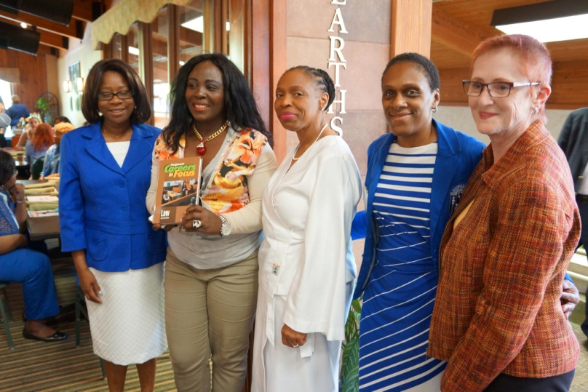
Since 2004, African Hope Committee has made tremendous progress in creating greater awareness and expanding literacy and educational opportunities for thousands of children, girls and adolescents in New York and in Africa. Our Book Drives has made this goal more possible, possible to give opportunity to a child even in the most remote areas in Africa to hold a book and to own that book.

Ensure inclusive and equitable quality education and promote lifelong learning opportunities for all
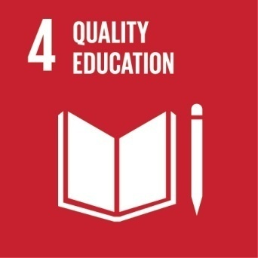 SDG#4: Quality Education
Quality education is one of 17 Global Goals that make up the 2030 Agenda for Sustainable Development after its adoption in September 2015. A Holistic approach is crucial for progress across the multiple goals.

The goals of AHC’s Education are:
- Solicitation of Books from donors
- Increasing Education and Literacy in Poor communities in Africa
- Increasing access to books for many children in Africa
- Creating and building Libraries in poor communities in Africa
- Increasing education awareness among women and young girls in Africa
- Increasing Global awareness through women and Girls empowerment and support services by creating group discussion to get feedback from their personal experiences about education
- Educating African women, young girls and youth to become self-sufficient and future leaders by first considering education
- Developing a plan of action to offer educational tool and resources to schools in Africa
- Engaging governments, politicians and other NGO’s to help add values on women and girls education
- Assist government in developing education policies that are gear toward promoting young girls and youth education.
- Developing and strengthening partnerships with government officials, leaders, women groups and institutions to help us meet our goals SDG4.
- Empower the francophone international communities to invest in English education since English is the main language spoken around the world
- Access more books for fundraising/ sustainability of the organization and to send to Africa..

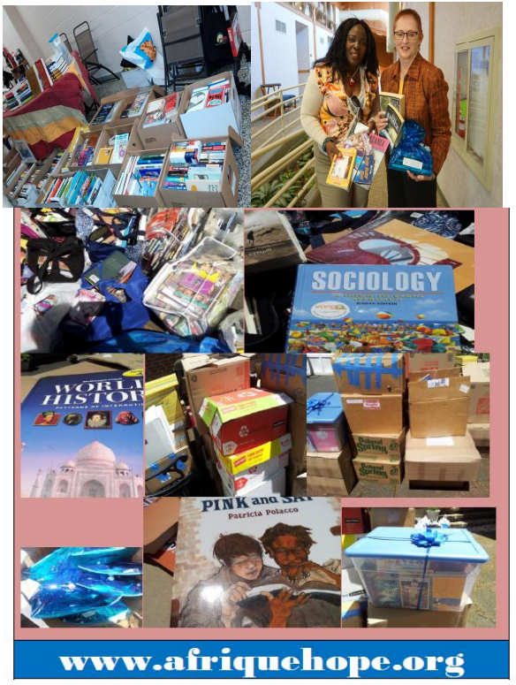
AHC Books’ Drive
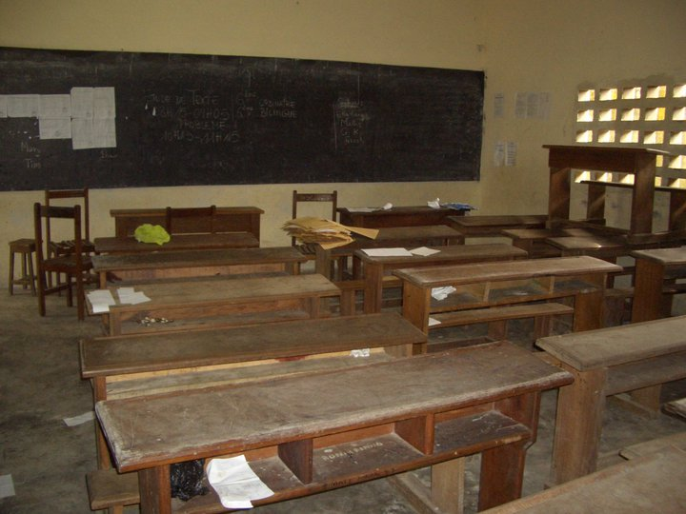A typical classroom in Cameroon/ Douala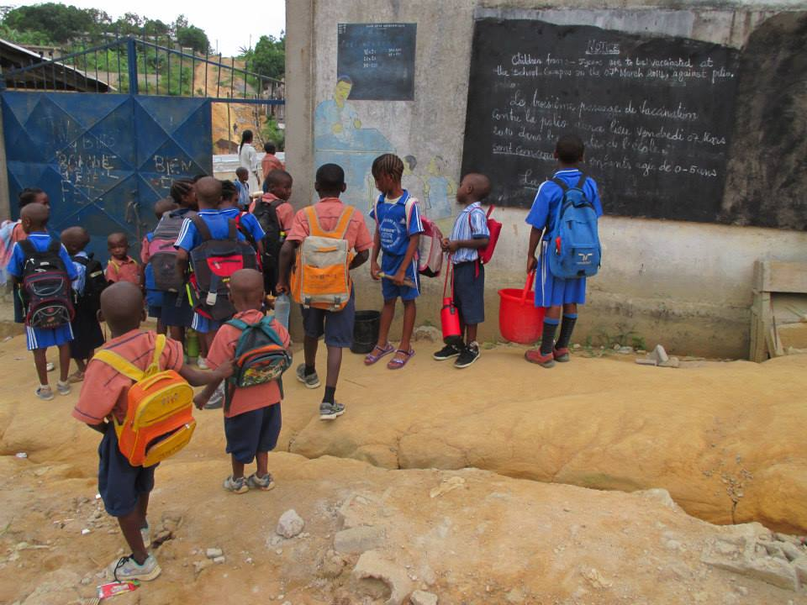 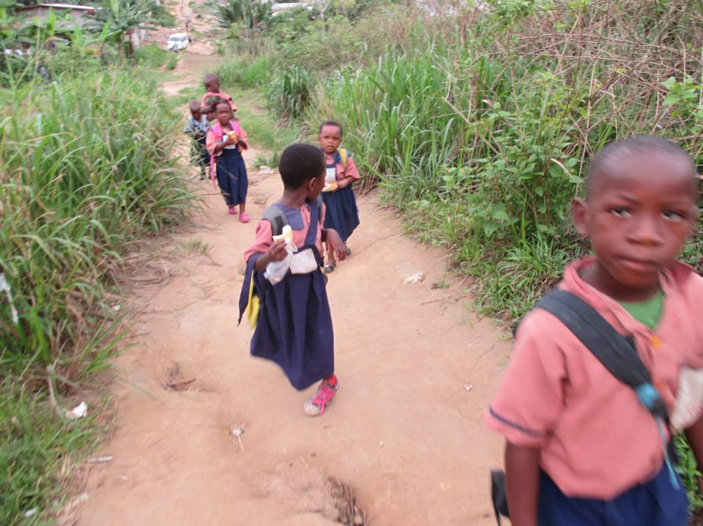
AHC would like to thank all our donors for giving us the opportunity to carry one of our Goals which is Education and Literacy for our children, women, girls, youth and family around the globe SDG#4. For the past 4 years, staff, board members, interns, volunteers and community participants have worked to assist the organization in picking books around the city, organize them and help load them to ship to places and countries where our partners are currently located and all work in areas of education and gender equality.
The African Hope Committee, who has been providing critical services in health, social and immigration for African and other immigrant communities in New York and in Africa since 2004, is seeking your support to address SDG.Under our goals mentioned above, we will first work to build and strengthen partnership around the globe to help achieve these goals. AHC will work with government officials in Africa to help expand literacy and build libraries in urban and rural areas. The books will be utilized by kindergarten, high school kids and college students in order to increase their reading, writing skills and critical thinking.
These books are collected since 2011 by staff, board members ,volunteers and interns and are donated to AHC by great people and corporations that believe in our mission such as Beta Zeta, CBS News Broadcast, Emblemhealth, Meffashion and many other individuals. This activity is still going on as we continue to promote education in the Black, African, minority and underserved community at a local, national and international level.
We are conducting book sales to raise funds to support and sustain our programs. The fund will continue to help AHC strives towards accomplishing our mission of being a bridge between mainstream service delivery systems and the African immigrant in New York City and the Africans living abroad.
AHC Book Drives “empower young people by providing them access to new and used books in your community, schools, libraries and promote a life skills program through reading and writing; support positive values, healthy habits, behavior modification and quality life style. – resulting in real life power.
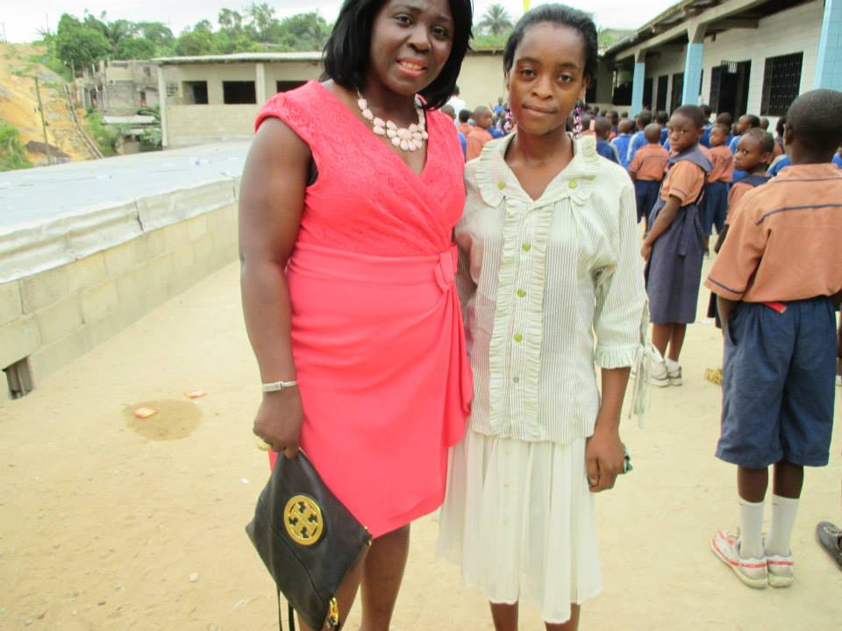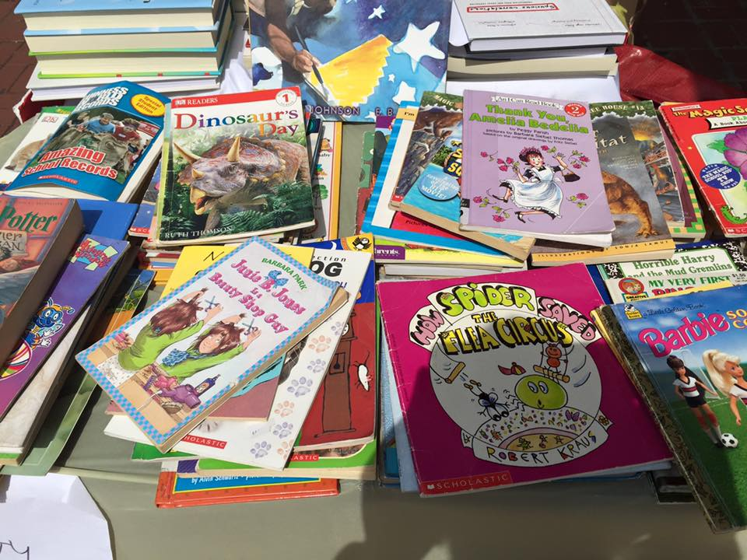

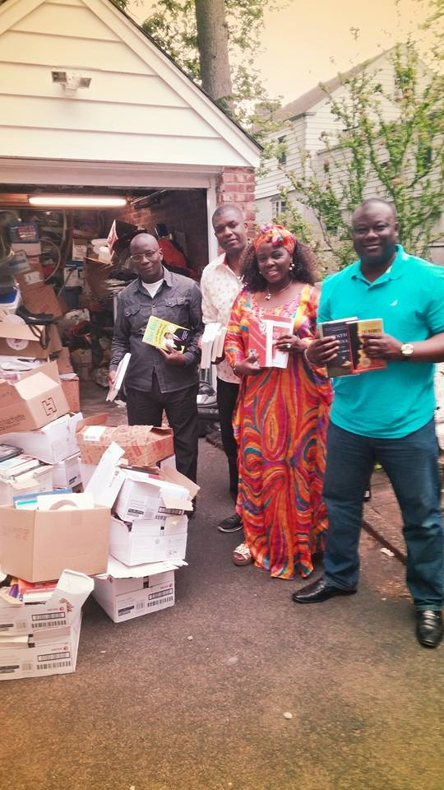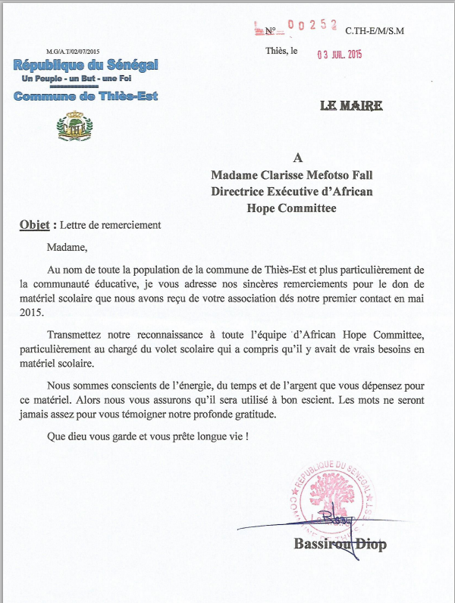
BOOKS WERE DONATED TO THE MAYOR OF THIES, SENEGAL RECEIVED BY HONORABLE BASSIROU DIOP WHO VISITED OUR STORAGE LAST SUMMER
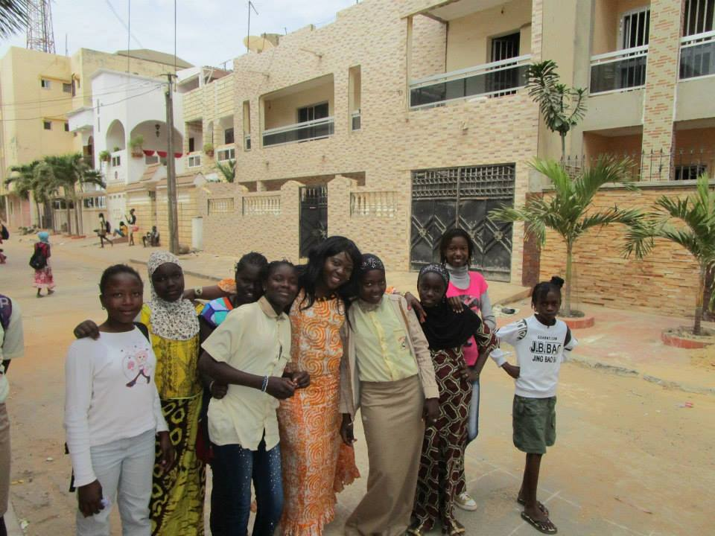
AHC’S EXECUTIVE DIRECTOR, CLARISSE MEFOTSO FALL IN SENEGAL, IN FEBRUARY WHERE SHE VISITED SCHOOLS AND EMPOWERED YOUNG GIRLS AND PROMOTED EDUCATION AND LITERACY.
His Honorable Pierre Wafo, President and CEO of Enfance Joyeuse du Cameroon received books in 2014 for the Center. The center has a huge library where kids have access to books. However, when AHC visited the center in 2013, the library mostly carried very old books and very few books in English. AHC was able to ship barrels of book for the center with Pierre wafo assistance, who paid for the shipping cost.
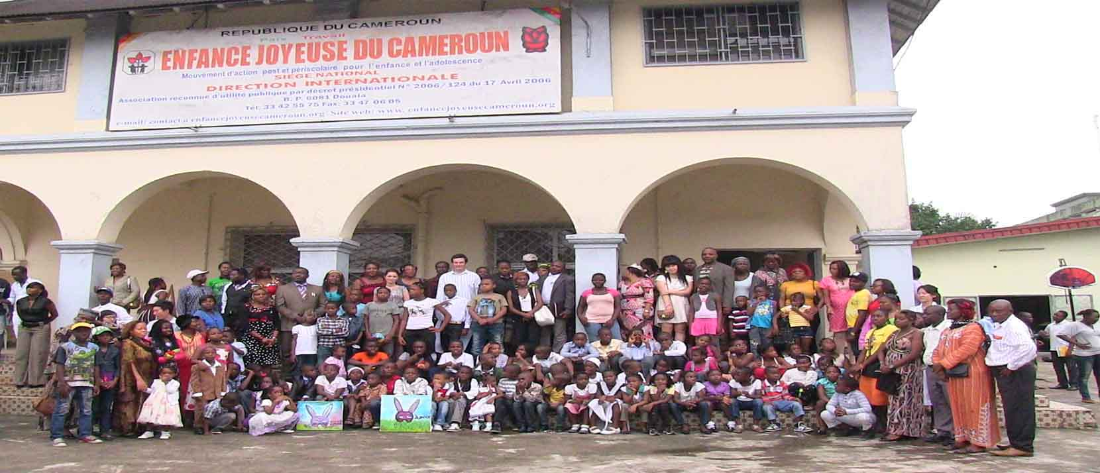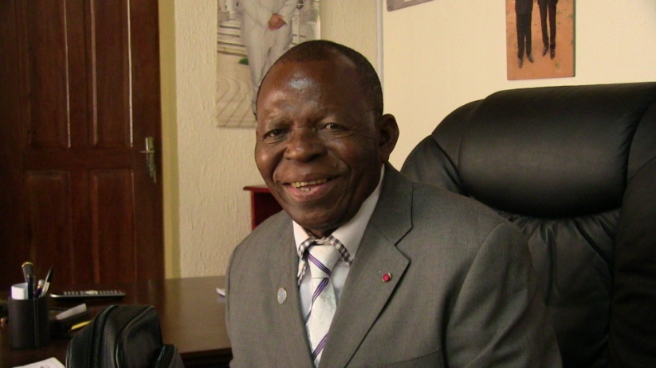
BOOKS WERE DONATED TO ENFANCE JOYEUSE DU CAMEROOM IN 2014
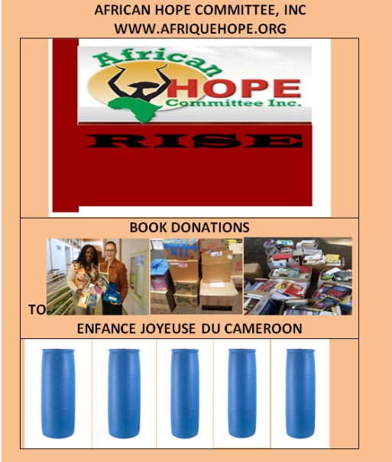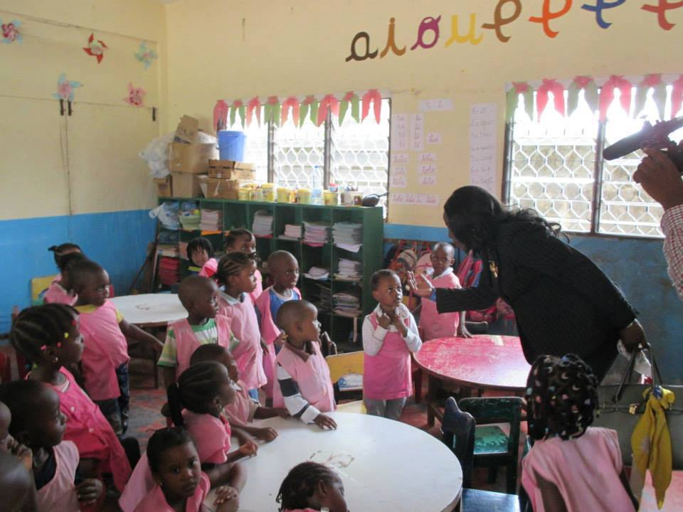
With the help and support of organizations, corporations and individuals here in America, AHC has collected and organized over 8,000 new and used books for children, youth and adults on a wide variety of subjects in which AHC strongly believe that over half of these books can benefit most schools in Africa.
BOOKS FOR A BETTER WORLD
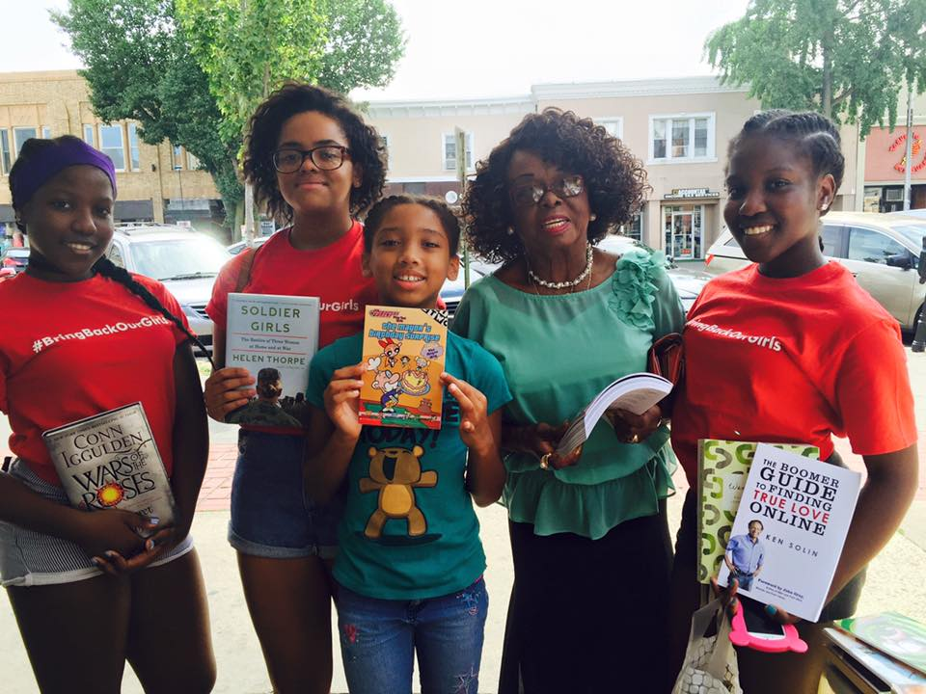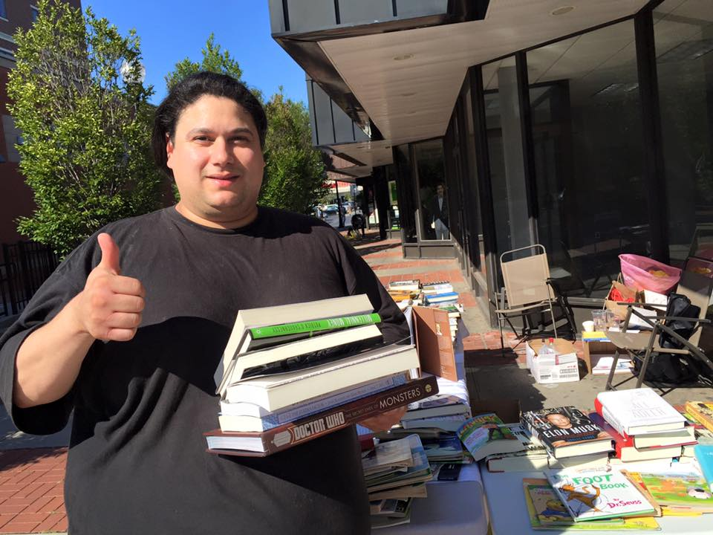
AHC book fundraising continues to help the global project sustain itself until we are able to secure proper funding to help implement one of our goals which is Quality Education for All!!! We have conducted several book fundraising. This year alone in August, we brought youth together to help sale books _ this was a 3 days sales in Englewood, New Jersey. The fund helped covered Back to school for few kids in Africa and was also used as a stipend to encourage the youth that participated on a Book sale. We thank all our donors and buyers that stopped on those 3 days to purchase the books and we are looking forward to plan many more book fundraising at many locations, such as schools, business hours for corporations and organizations. Contact info@afriquehope or 212-862-9010 if you would like to purchase a book or donate for our cause.
COMMUNITY EMPOWERMENT IN NEW YORK CITY
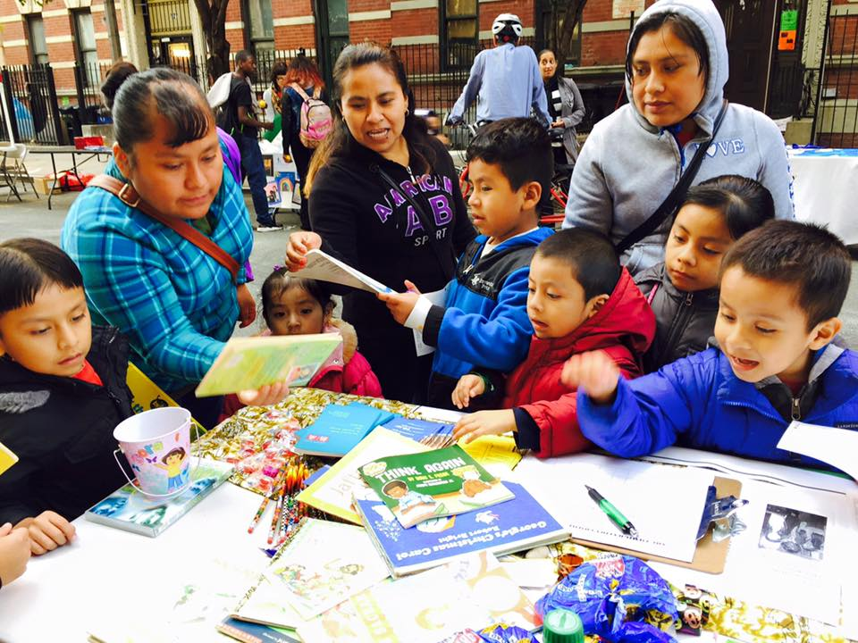
COMMUNITY EMPOWERNEMNT AND SUSTAINABLE DEVELOPMENT ARE WAYS TO ENCOURAGE PEOPLE TO PARTICIPATE TO MANY ACTIVITIES GEARED TOWARD PUTTING COMMUNITIES DEVELOPMENT VALUES INTO ACTION!!
AHC encourages learning, equality, participation, togetherness, co-operation and leadership of women, young girls, youth, men and families!! Picture above are pictures from a community empowerment fair and from Mr. Africa USA Pageant in New York, Harlem. We work in a co-operative ways, which build positive relationships with our partners, identifying common messages, developing and maintaining links through social media to reach the public at local, national and international levels.
PICKING UP BOOKS FROM OUR PROUD DONORS
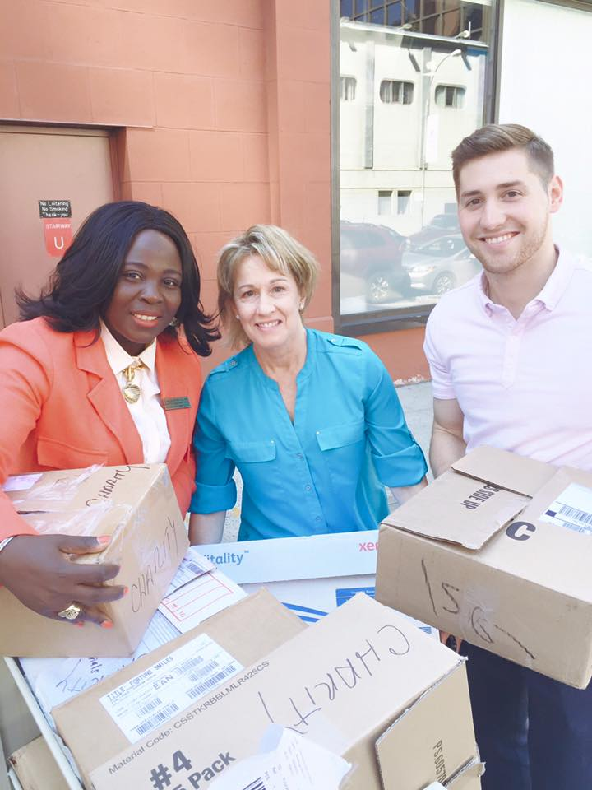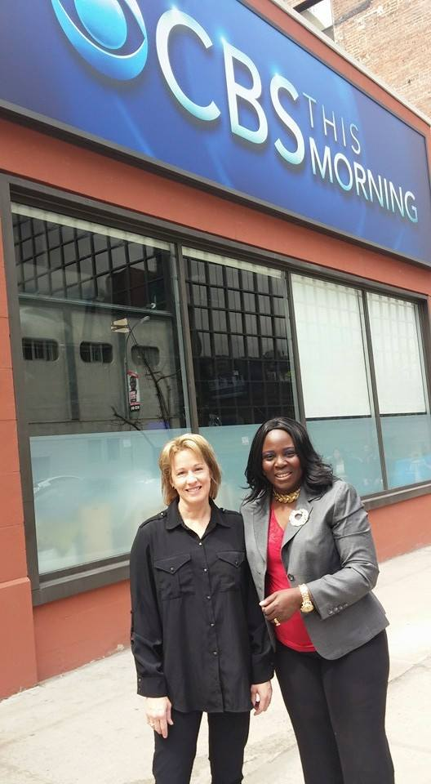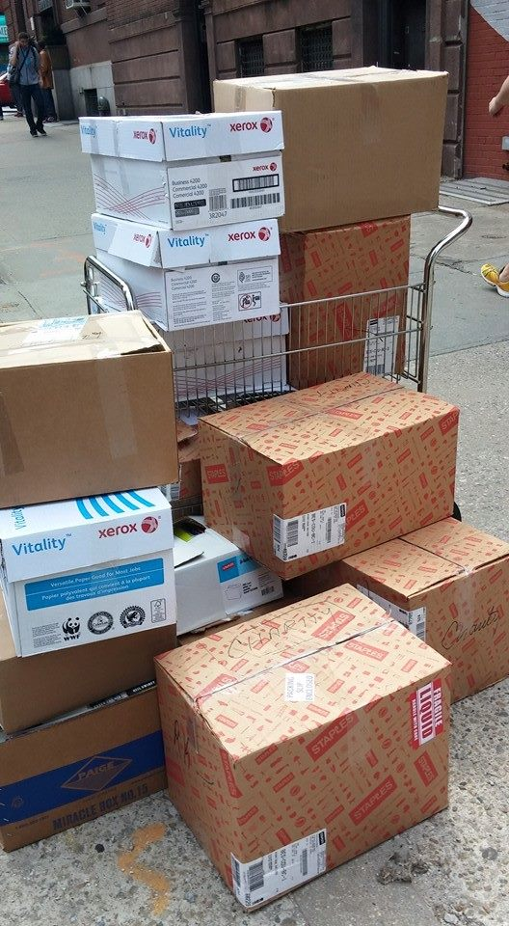
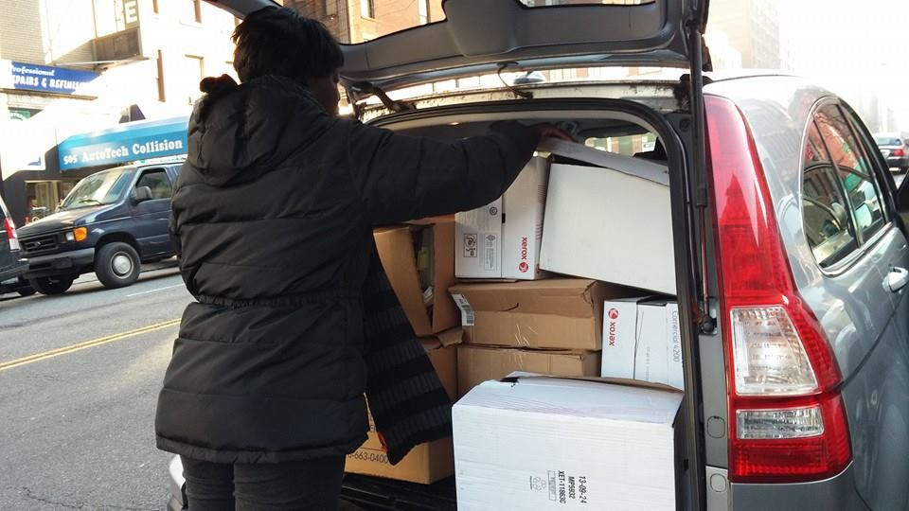
Book Drives: Book donors primarily come from generous people and corporation that believe in Education and literacy as well as quality education for all! For the last 4 years, AHC‘s staff picked up and collected books from several donors where one of our major Book donor remain to be CBS News Broadcast!!! We thank staff and our fans at CBS News for joining our cause!!!! Pictures above are staff assisting picking up books at CBS.

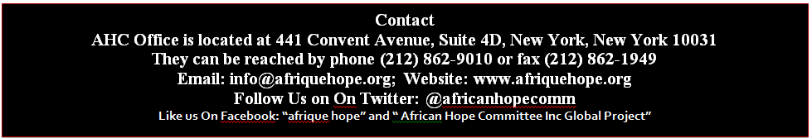
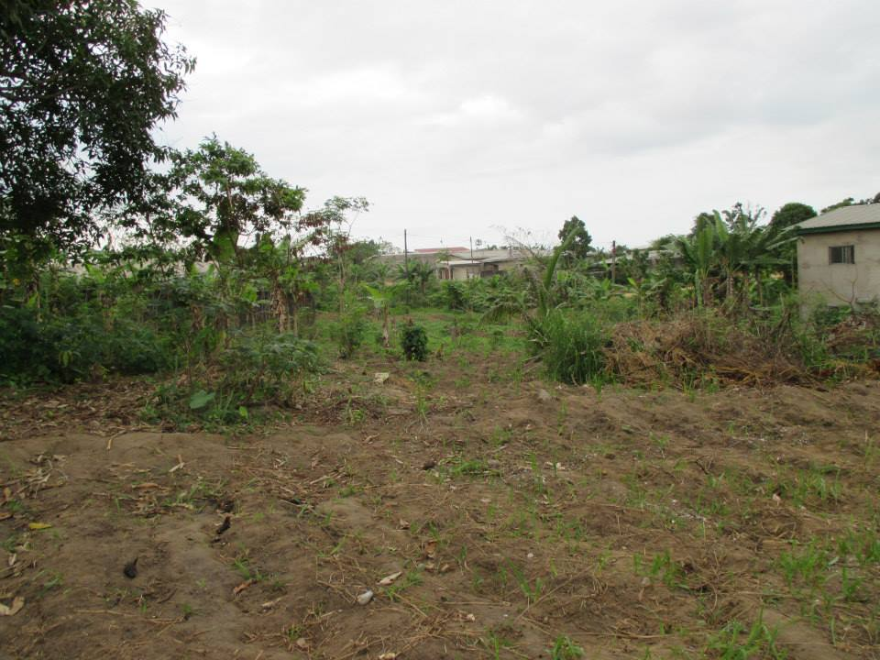
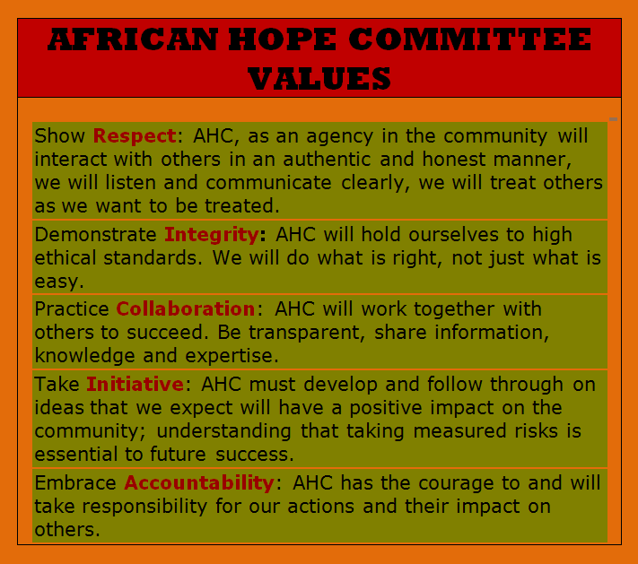
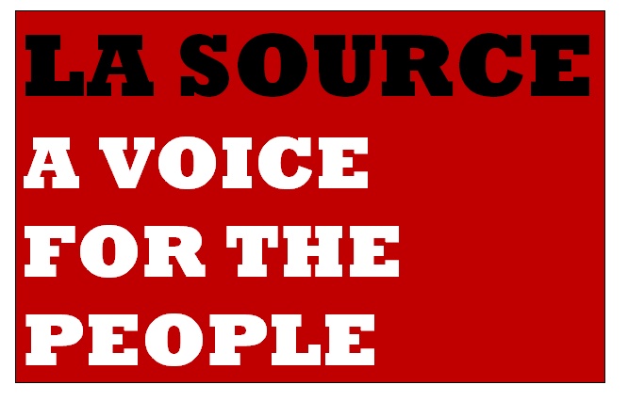
WWW.AFRIQUEHOPE.ORG

